**Assignment**

**Name:- Sehrish Afzal[fa18-bse-059]**

**Baneen Bukhari [fa18-bse-017]**

**Section:- 6b**

**Date:- 19th may 2021**

**Course:- Game Development**

**Question:-**

**Document the primary game play mode of your project.**

In this game the model we are using Agile Model:-

In this model the given product(project) is broken down into a set of features and hence it is used for quickly delivering a working product and so considered as a very rational development method. in this project game some tasks are performed by me and some are performed by my group member. In this game I make a menu page and some task on user interface and audio setting is done by my group member.in this model we have the chance to change or add items with respect to time.

In Primary game play mode we are mainly spending more time at user interface in this mode different fruits are cut by the user and a user have three lives to live and if user cut the bomb instead of fruit they lose their lives. So this is the main task performing at primary game play mode

User interface of the game:-

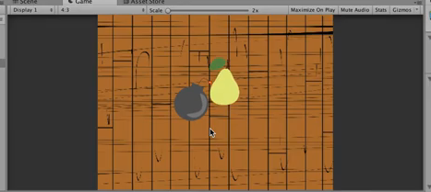

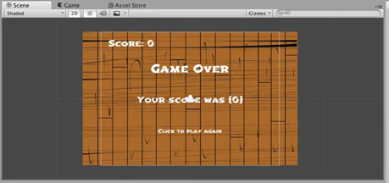

In this game the buttons that I create is

Play button

Score button

In this game user switch the modes when user click on play button it moves to game play mode and when it clicks on score button so it moves to score screen so these are some basic mode that we may switches easily.

Game Modes

Classic Mode:

This is the standard Fruit Ninja game mode, complete with all fruit, bombs and standard play.

Zen Mode:

This mode allows you to play the game without having to worry about the bombs invading your screen.

In classic mode the challenges users are facing is that they lose lives due to the cutting of bombs but after Zen mode it becomes easy for users to play the game.